**BIG DATA ANALYTICS AND VISUALIZATION LAB**

A Lab Journal Submitted in Fulfillment

of the Degree of

**MASTER**

**In**

**COMPUTER APPLICATION**

**Year 2022-2023**

By

**Mr. Gupta Vaibhav Ravindra Kalyani**

**(Seat No-806062)**

**(Application Id-169591)**

Under the Guidance of

**Prof. Bharti**



Institute of Distance and Open Learning

Vidya Nagari, Kalina, Santacruz East – 400098.

University of Mumbai

**PCP Center**

**Satish Pradhan Dnyanasadhana College,**

**Thane.**



**Institute of Distance and Open Learning**

Vidya Nagari, Kalina, Santacruz East – 400098.

***CERTIFICATE***

This is to certify that, this project report entitled **“Big Data Analytics and Visualization Lab”** is a record of work carried out by **Mr. Gupta Vaibhav Ravindra Kalyani (Seat no-806062),** student of **MCA semester-III** class and is submitted to University of Mumbai, in partial fulfilment of the requirement for the award of the degree of **Master in Computer Application**. The project report has been approved.

___________ ____________ ____________

Guide External Examiner Coordinator – M.C.A

**Declaration**

I declare that this written submission represents my ideas in my own words and where other's ideas or words have been included, I have adequately cited and referenced the original sources. I also declare that I have adhered to all principles of academic honesty and integrity and have not misrepresented or fabricated or falsified any idea/data/fact/source in my submission. I understand that any violation of the above will be cause for disciplinary action by the Institute and can also evoke penal action from the sources which have thus not been properly cited or from whom proper permission has not been taken when needed.

-----------------------------------------

(Signature)

**Gupta Vaibhav Ravindra Kalyani**

Seat No-806062

Date:

Place:

**ACKNOWLEDGMENT**

After the completion of this work, words are not enough to express my feelings about all those who helped me to reach my goal; feeling above this is my indebtedness to the almighty for providing me this moment in my life.

It’s a great pleasure and moment of immense satisfaction for me to express my profound gratitude to my project guide, **Prof. Bharti** whose constant encouragement enabled me to work enthusiastically. His perpetual motivation, patience and excellent expertise in discussion during progress of dissertation work have benefited me to an extent, which is beyond expression. His depth and breadth of knowledge of Engineering field made me realize that theoretical knowledge always help to develop efficient operational software, which is a blend of all core subjects of the field. The completion of this project would not have been possible without his encouragement, patient guidance and constant support.

I would like to thank all staff members for their valuable cooperation and permitting me to work in the computer labs.

Special thanks to my colleagues and friends for providing me useful comments, suggestions and continuous encouragement.

Finally, I thanks my family members, for their support and endurance during this work.

----------------------------------

**Mr. Gupta Vaibhav Ravindra Kalyani**

(Seat No:806062)

**Index**

|  |  |
| --- | --- |
| **Practical No** | **Details** |
| 1 | Install, configure and run Hadoop and HDFS ad explore HDFS. |
| 2 | Implement word count / frequency programs using MapReduce |
| 3 | Mongo DB: Installation and Creation of database and Collection CRUD Document: Insert, Query, update and Delete Document |
| 4 | Hive: Introduction Creation of Database and Table, Hive Partition, Hive Built in Function and Operators, Hive View and Index. |
| 5 | Visualization: Connect to data, Build Charts and Analyze Data, Create Dashboard, Create Stories using Tableau. |

**Practical No. 1**

**Aim: Install, configure and run Hadoop and HDFS ad explore HDFS.**

**Step 1: Download and install VirtualBox**

Go to the website of Oracle VirtualBox and get the latest stable version from the following site

https://[www.virtualbox.org/](http://www.virtualbox.org/)

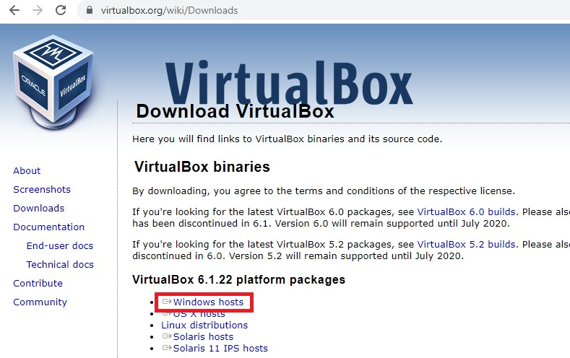click on ‘Download’’

You will get VirtualBox-6.1.22-144080-Win.exe file downloaded. Double click and run it. Click on next.

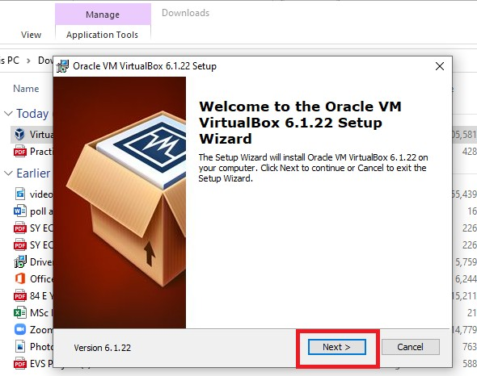

Click on ‘next’ without changing the default folder as shown below:

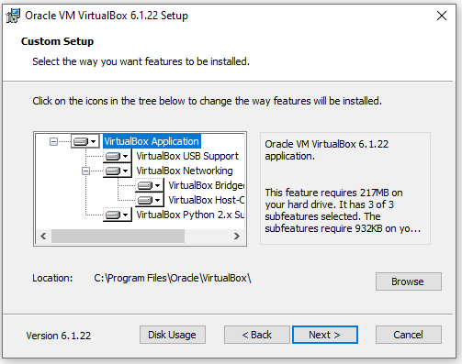

Again, click on next as shown below:

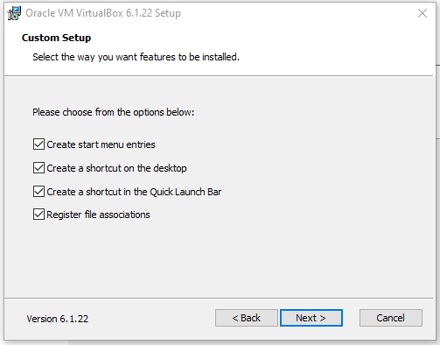

Finally, click on ‘Yes’.

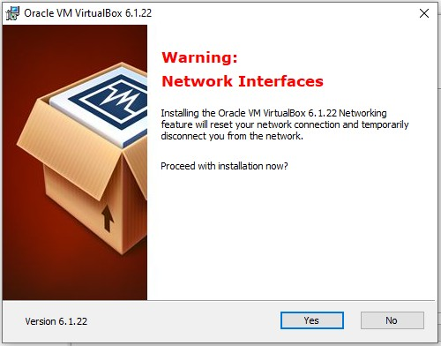

Click on ’Install’.

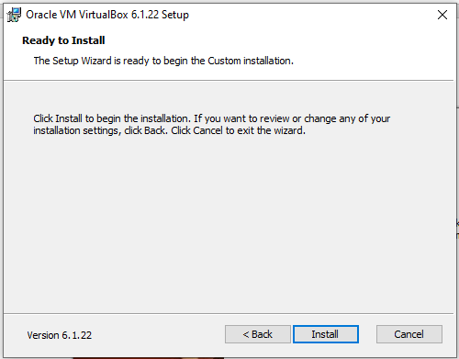

It may ask you for the permission to install, click ’yes’ to allow. Select ‘Install’ as shown below:

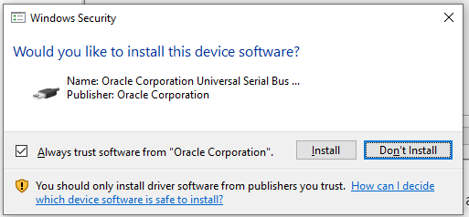

You will get the screen as shown below:

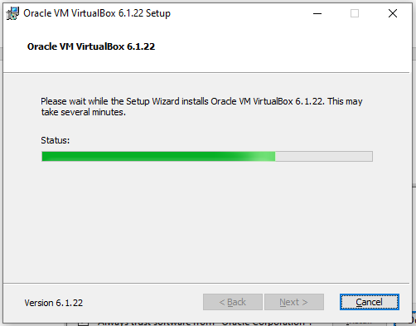

Click on ‘Finish’ to finish Installation of virtual box.

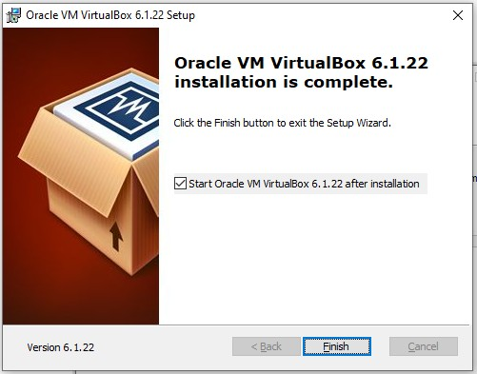

You will get the following screen:

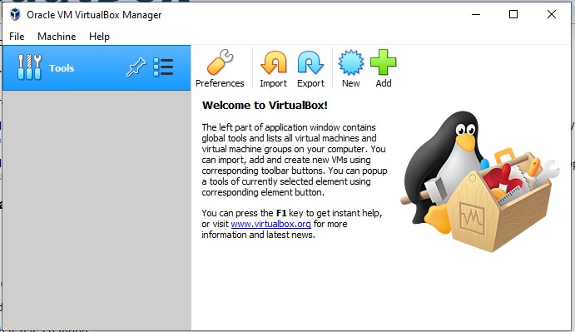

**Step 2: download Ubuntu**

Download iso file ubuntu-20.04.2.0-desktop-amd64; which is required to install Ubuntu.

Browse ubuntu.com

Click on download and 20.04 LTS as shown below:

LTS stands for Long term support

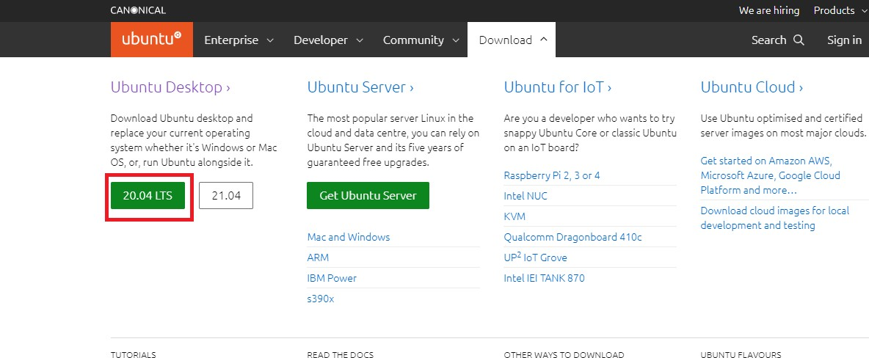

You will get file, which may take few minutes to download.

Now, click on ‘New’ to virtual box and write Name as ‘Ubuntu’ as shown below:

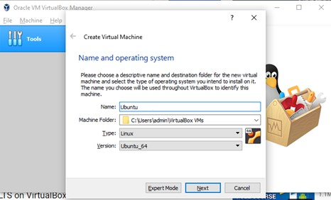

Click on ‘Next’.

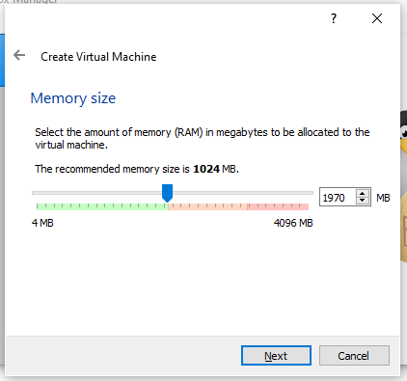

Here, you allow memory size up to green indicator (1970 MB).

Click on ‘Next’.

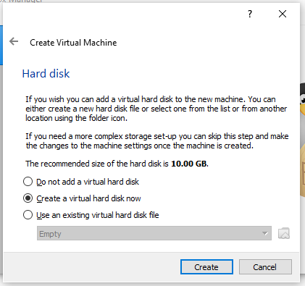

Don’t change anything in this screen and click on ‘Create’.

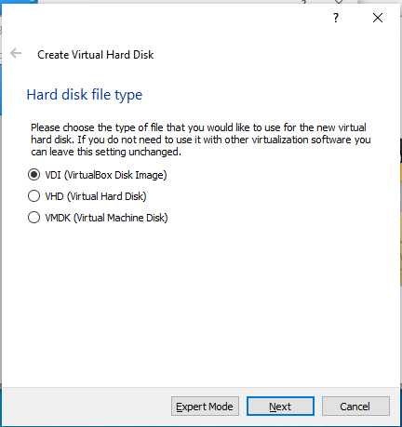

Click on ‘Next’, keeping the selection as it is (on VDI).’

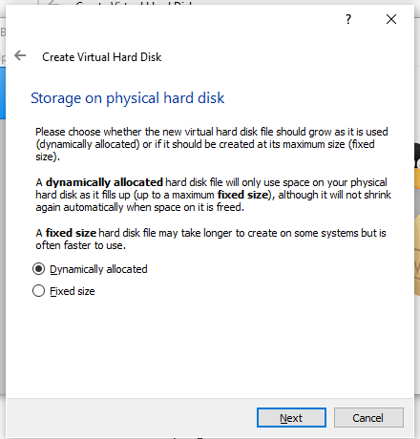

Keep this screen also as it is and click on ‘Next’.

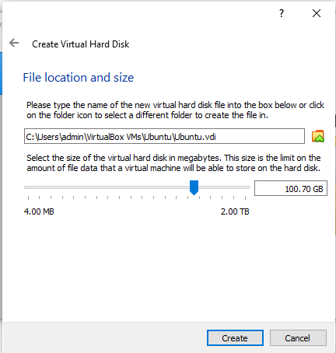

Keep the file location as it is but preferably keep size 100 GB and click on

‘Create’.

You may see the following screen having Ubuntu on Virtual Machine.

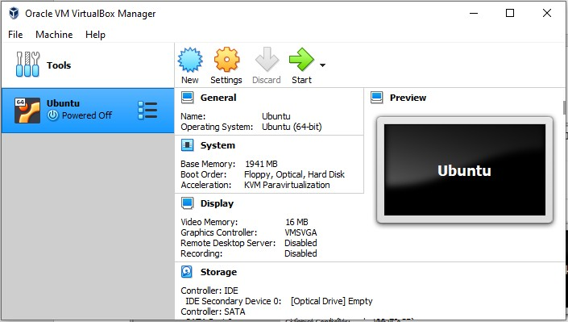

Select ‘General’ -> ’ Basic’ as shown below:

You may change the name from Ubuntu to Ubuntu 20.04

Click on Ubuntu and then click on settings option as shown below: Select bidirectional in ‘General’ -> ’ Advanced’ as shown below:

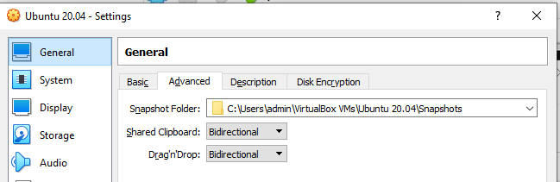

Go to ‘System’ option and change the processor up to green bar, usually 4.(if it allows)

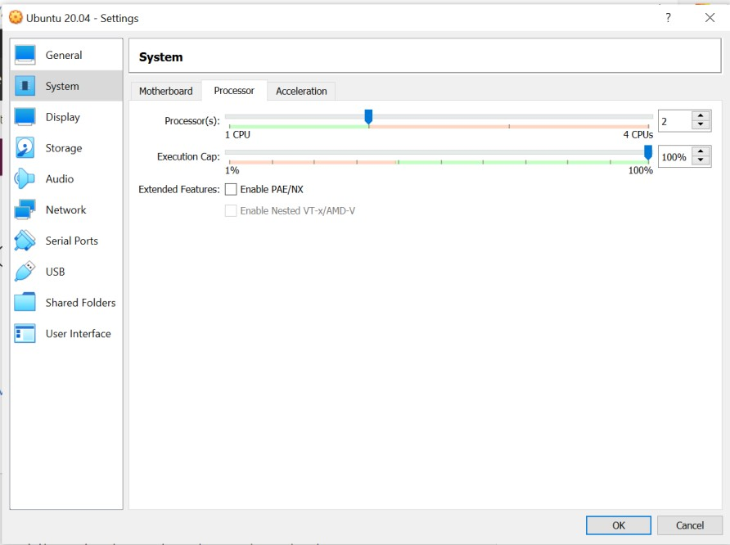

Cut and paste your ubuntu .iso file from current folder to C:\Users\ADMIN\VirtualBox VMs\Ubuntu 20.04 folder.

Click on ‘Storage’ and click on ‘Empty’ followed by ‘Choose a disk file’ as shown

below:

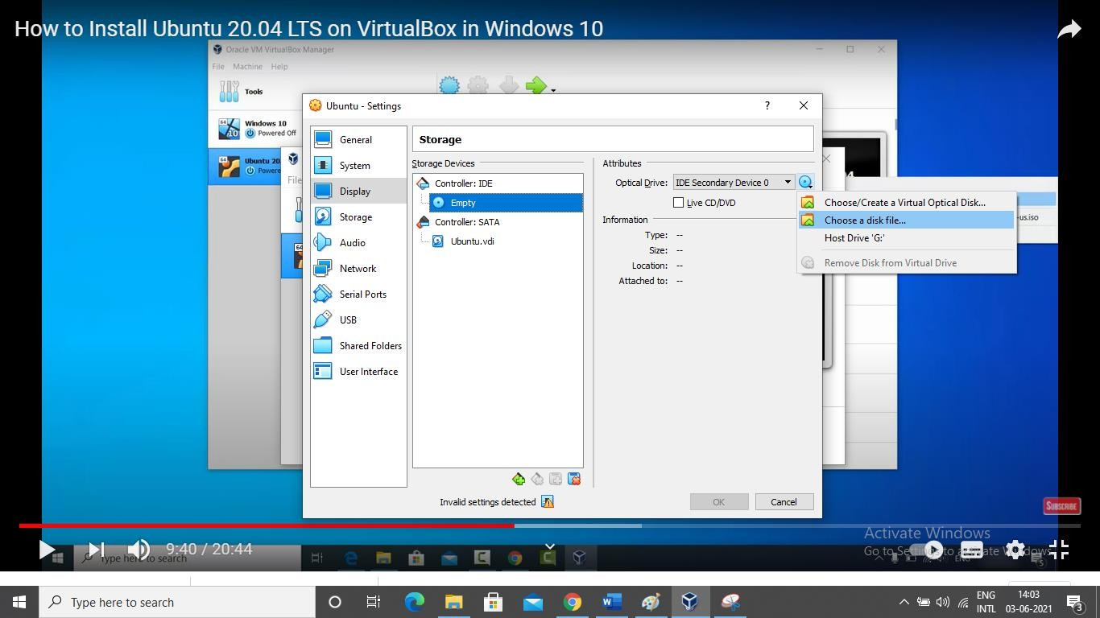

Browse the folder where you have selected ubuntu iso file.

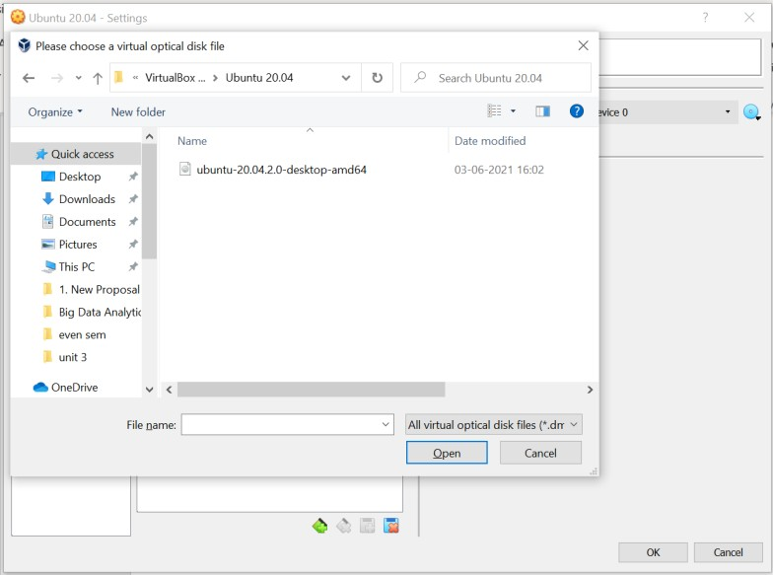

Click on Ubuntu….iso file and click on open and then click on ok.

Click on Ubuntu -> start button.

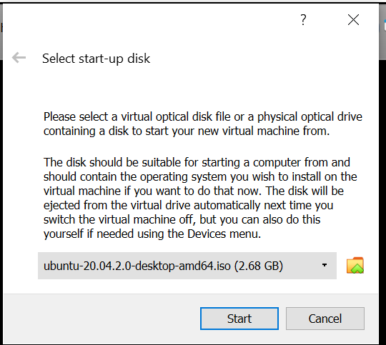

Again, click on ‘Start’ button. It will show you the following screen.

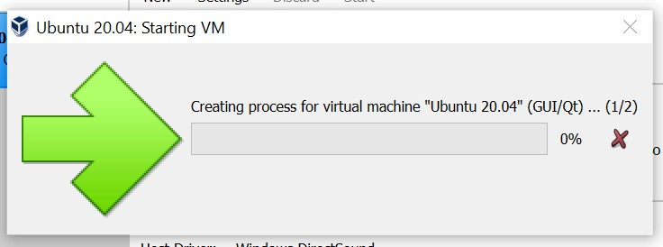

And simultaneously one more screen as follows:

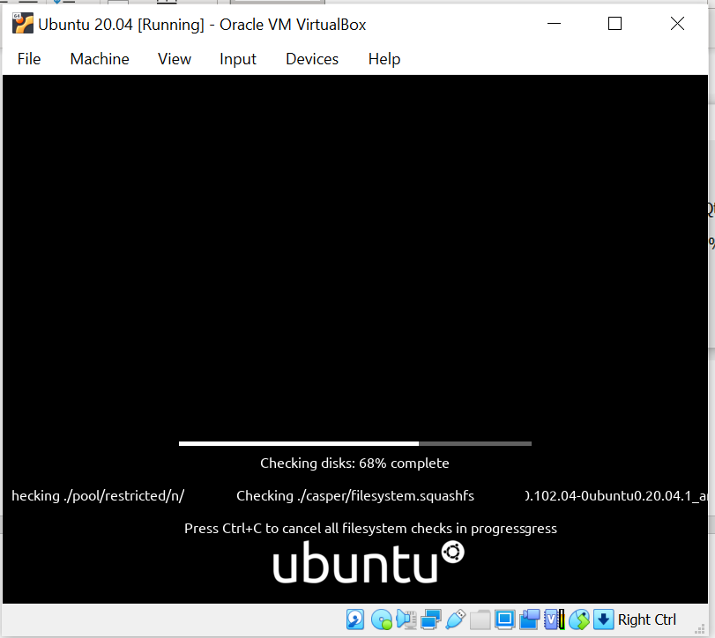

Keep on closing all warnings.

Next you will get following screen automatically.

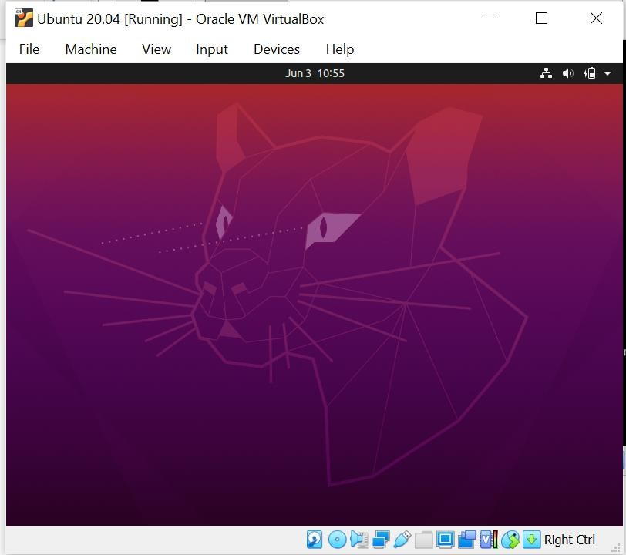

Select language -> English and click on ‘Install Ubuntu’.in ‘Keyboard Layout’ screen, select ‘English UK’. Click on ‘Continue’.

Select the checkbox for third party software as shown below:

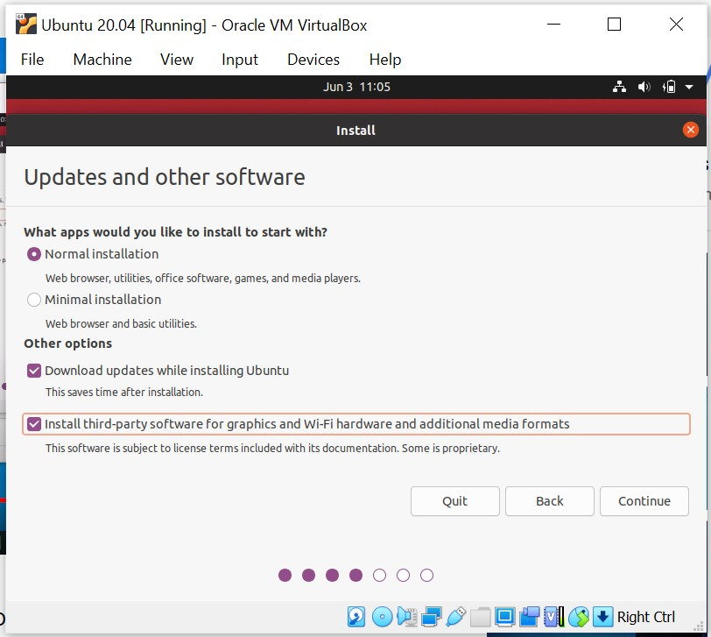

Click on ‘continue’.

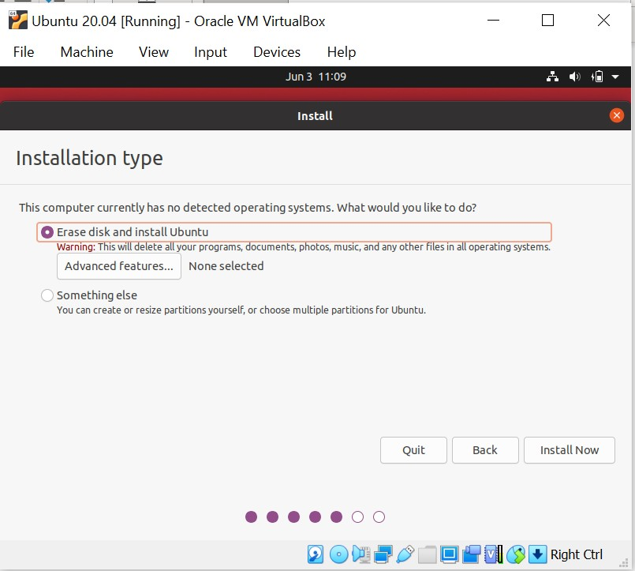

Select Erase disk and Install Ubuntu and click on **‘Install Now’**. Click on **‘Continue’** on the next screen.

Select “Kolkata” for “where are you?” and click on **‘Continue’.**

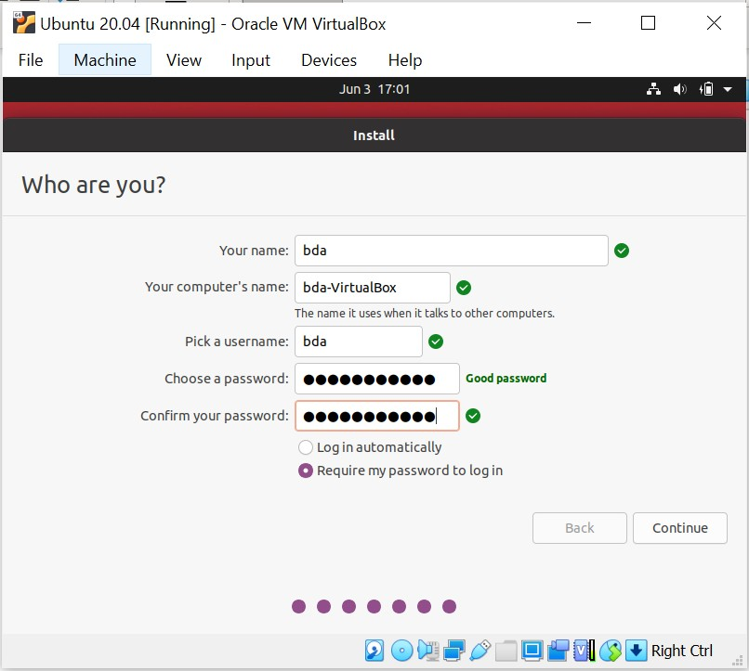

Click on continue after entering name, company name, username, password and confirm your password.

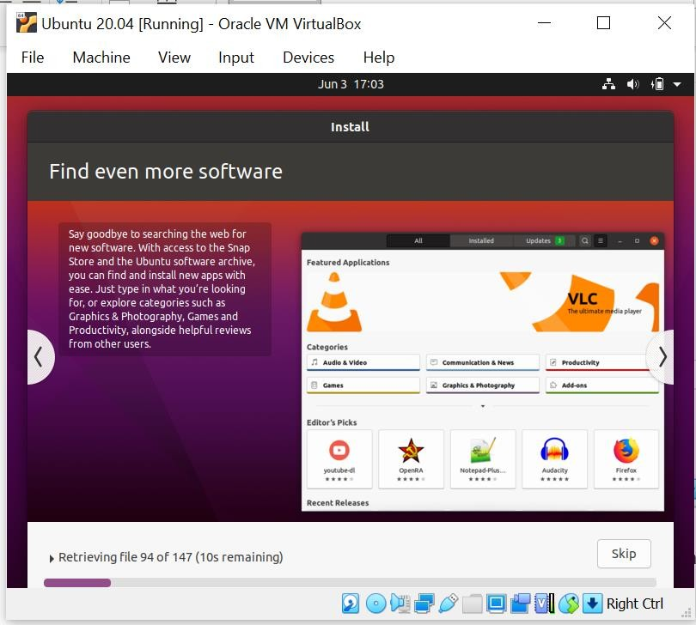

Installation of Ubuntu started. Click on finish once installation done. Click on restart and press Enter key.

# Step 3 Install Hadoop

Login to ubuntu

Some keys may change like you try to type @ and it types “.

** please refer to note - Some Keys for Ubuntu under UK keyboard layout – at the end. Search for Ubuntu terminal on search bar, after login done.

Apply following commands from ubuntu terminal

$ sudo apt update

$ sudo apt install default-jdk

$ ava -version'

$ wget <https://hadoop.apache.org/release/3.2.2.html/hadoop-3.2.2.tar.gz>

$ tar xzvf hadoop-3.2.2.tar.gz

$ sudo mv hadoop-3.2.2 /usr/local/hadoop

$ readlink -f /usr/bin/java | sed "s:bin/java::"

# : Configuring Hadoop’s Java Home; To begin, open hadoop-env.sh

$ sudo nano /usr/local/hadoop/etc/hadoop/hadoop-env.sh

File will be opened. Add the following line at the end of .sh file export JAVA_HOME=/usr/lib/jvm/java-11-openjdk-amd64/

to save the changes in the file, press ctrl and x together. then press Y

then press Enter key

then apply following commands:

$ /usr/lib/jvm/java-11-openjdk-amd64/

**Step 4: Running Hadoop**

$ /usr/local/hadoop/bin/hadoop

$ mkdir ~/input

$ cp /usr/local/hadoop/etc/hadoop/*.xml ~/input

We can use the following command to run the MapReduce hadoop mapreduce-examples program, a Java archive with several options. We’ll invoke its grep program, one of the many examples included in hadoop-mapreduce-examples, followed by the input directory, input and the output directory grep_example. The MapReduce grep program will count the matches of a literal word or regular expression. Finally, we’ll supply the regular expression allowed[.]* to find occurrences of the word allowed within or at the end of a declarative sentence. The expression is case-sensitive, so we wouldn’t find the word if it were capitalized at the beginning of a sentence:

$ /usr/local/hadoop/bin/hadoop jar /usr/local/hadoop/share/hadoop/mapreduce/hadoop- mapreduce-examples-3.2.2.jar grep ~/input ~/grep_example 'allowed[.]*'

$ cat ~/grep_example/*

**Practical No. 2**

**Aim: Implement word count / frequency programs using MapReduce.**

We have to write the splitting parameter, Map function logic and Reduce function logic. The rest of the remaining steps will execute automatically.

**Prerequisites:**

1. Hadoop-3.3.1
2. JDK 8
3. Eclipse

We have already installed Hadoop and Java successfully in the first practical.

To install Eclipse on ubuntu 20.04, go to the terminal and run command

$ sudo snap install --classic eclipse

**Steps**

1. Open Eclipse> File > New > Java Project >( Name it – WordCountMR) > Finish.

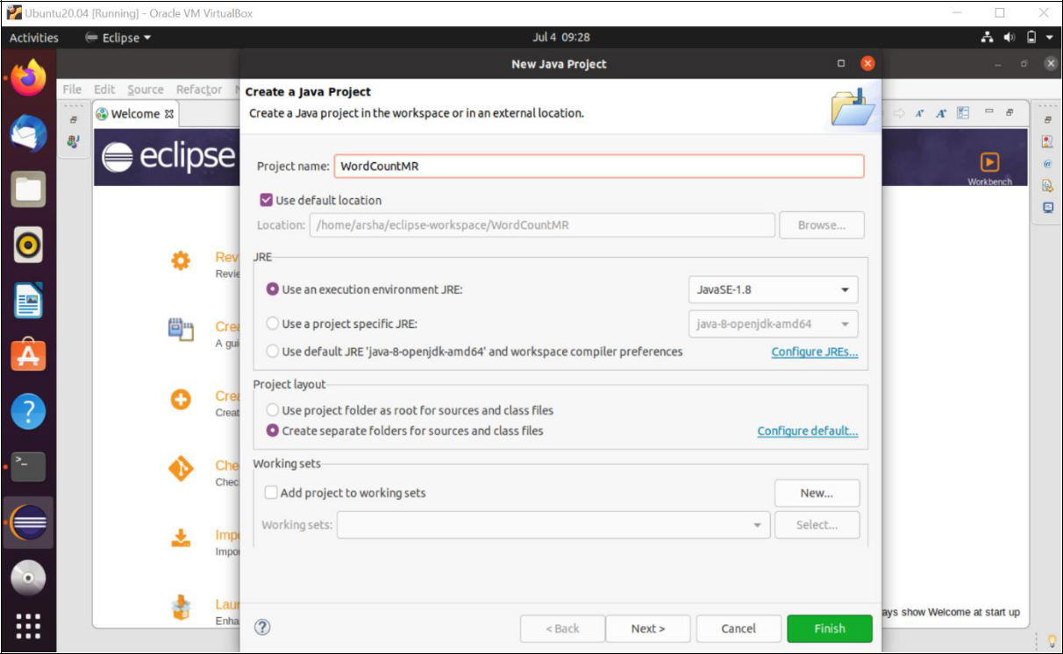

1. Right Click on project WordCountMR > New > Package ( Name it - PkgWordCount) > Finish.

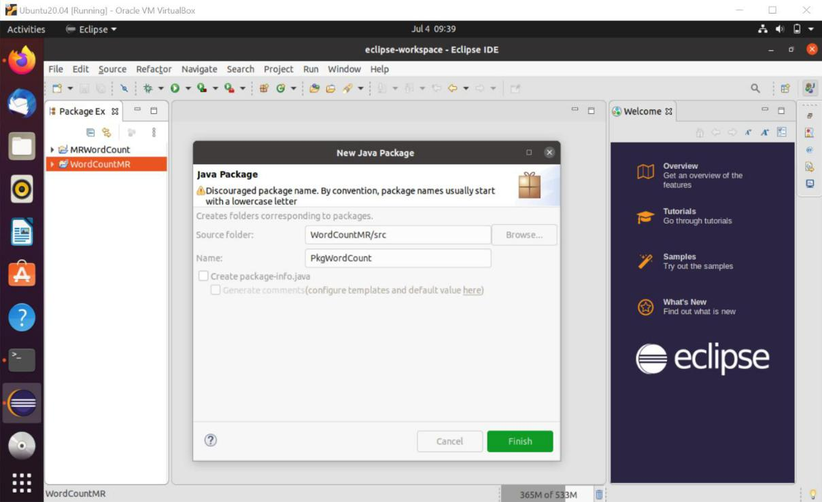

1. Right Click on Package PkgWordCount > New > Class (Name it - WordCount).

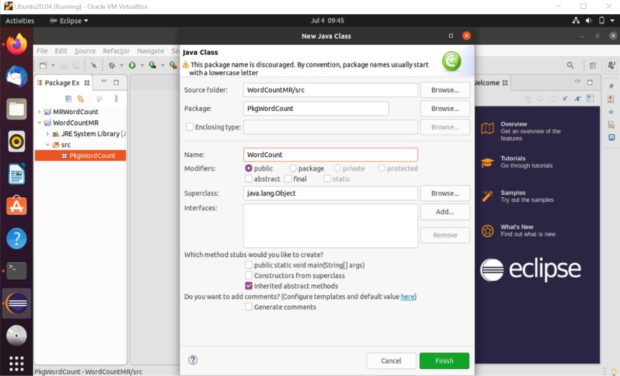

4. Add Following Reference Libraries:

Right Click on Project > Configure Build Path> Add External JARs

1. All jar under **/hadoop-3.3.1/share/hadoop/mapreduce**
2. All jar files under **/hadoop-3.3.1/share/hadoop/common/lib**
3. /hadoop-3.3.1/share/hadoop/common**/hadoop-common-3.3.1.jar**> Apply and Close.

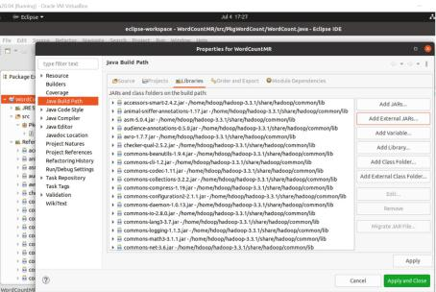

5. Type the following code:

package PkgWordCount;

import java.io.IOException;

import org.apache.hadoop.conf.Configuration; import org.apache.hadoop.fs.Path;

import org.apache.hadoop.io.IntWritable; import org.apache.hadoop.io.LongWritable; import org.apache.hadoop.io.Text; import org.apache.hadoop.mapreduce.Job; import org.apache.hadoop.mapreduce.Mapper; import org.apache.hadoop.mapreduce.Reducer;

import org.apache.hadoop.mapreduce.lib.input.FileInputFormat; import org.apache.hadoop.mapreduce.lib.output.FileOutputFormat; import org.apache.hadoop.util.GenericOptionsParser;

public class WordCount{

@SuppressWarnings("deprecation")

public static void main(String [] args) throws Exception{ Configuration c=new Configuration();

String[] files=new

GenericOptionsParser(c,args).getRemainingArgs();

Path input=new Path(files[0]); Path output=new Path(files[1]); Job j=new Job(c,"wordcount"); j.setJarByClass(WordCount.class); j.setMapperClass(MapForWordCount.class); j.setReducerClass(ReduceForWordCount.class); j.setOutputKeyClass(Text.class); j.setOutputValueClass(IntWritable.class); FileInputFormat.addInputPath(j, input); FileOutputFormat.setOutputPath(j, output); System.exit(j.waitForCompletion(true)?0:1);

}

public static class MapForWordCount extends Mapper<LongWritable, Text, Text, IntWritable>{

public void map(LongWritable key, Text value, Context con) throws IOException, InterruptedException{

String line = value.toString();

String[] words=line.split(" ");

for(String word: words ){

Text outputKey = new Text(word.trim()); IntWritable outputValue = new IntWritable(1); con.write(outputKey, outputValue);

}

}

}

public static class ReduceForWordCount extends Reducer<Text, IntWritable, Text, IntWritable>{

public void reduce(Text word, Iterable<IntWritable> values, Context con) throws IOException, InterruptedException{

int sum = 0;

for(IntWritable value : values){

sum += value.get();

}

con.write(word, new IntWritable(sum));

}

}

}

The above program consists of three classes:

* Driver class (Public, void, static, or main; this is the entry point).
* The Map class which **extends** the public class Mapper<KEYIN,VALUEIN,KEYOUT,VALUEOUT> and implements the Map function.
  + The Reduce class which extends the public class Reducer<KEYIN,VALUEIN,KEYOUT,VALUEOUT> and implements the Reduce function.

1. Make a jar file
   * + Right Click on Project> Export
     + Expand Java tab>JAR file>Next

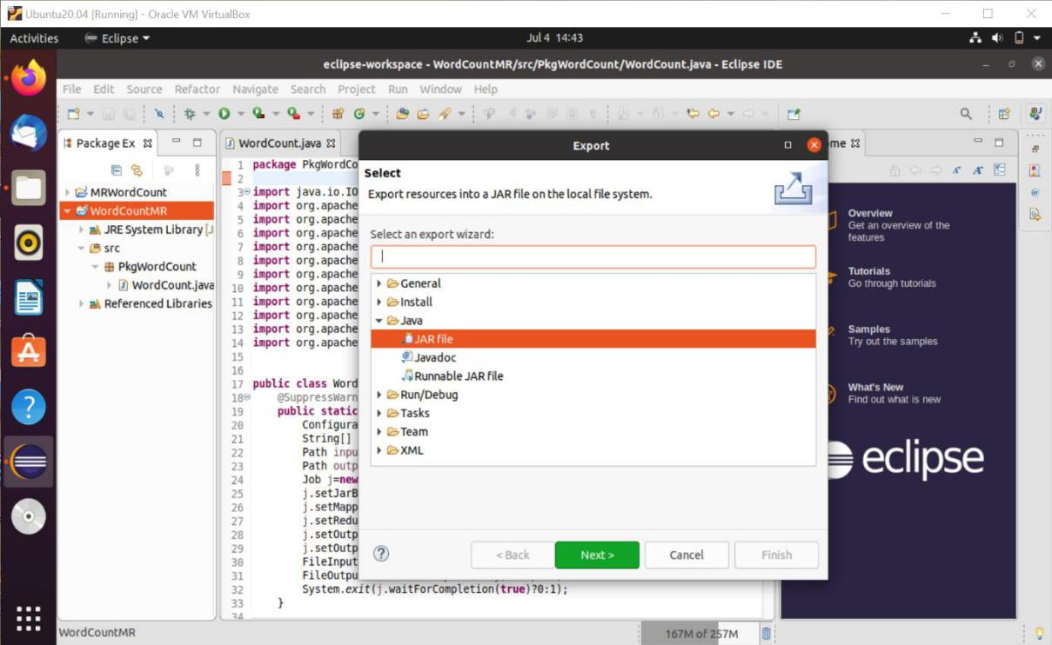

* Select the resources to export WordCountMR > Name the JAR file (WordCount.jar) > Finish

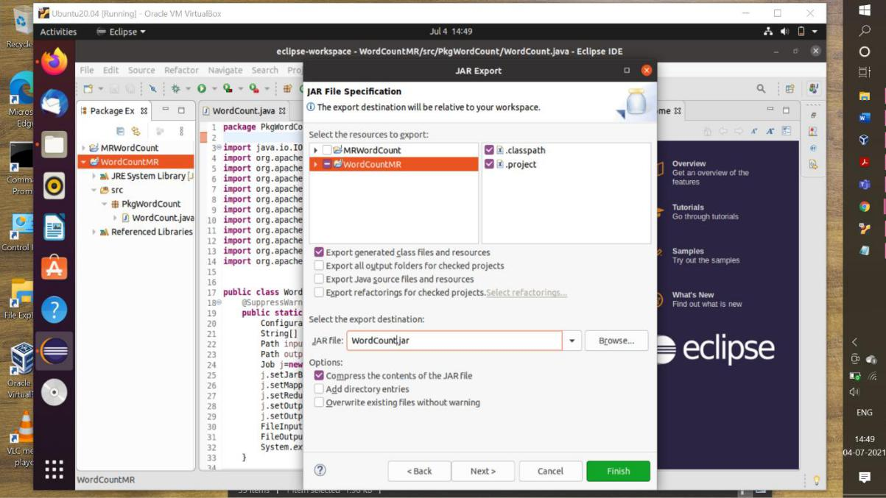

1. Create a text file (data.txt)
   * By default, when we right-click inside anywhere in Ubuntu Nautilus file manager, it will not give us the “New document” option. Thus, to get this missing option, we need to run a command.
   * Open Ubuntu command terminal. Run command-touch ~/Templates/Text\ document
   * Now, go to your Desktop > Right-click > New document > Text document (Name it – data.txt) and Add some words in it.
2. Now put this data.txt in HDFS.
   * Open terminal and login with your hadoop user and change directory to hadoop-3.3.1/sbin. Run command-

cd hadoop-3.3.1/sbin

* + Now start DFS and yarn services. Run commands –

./start-dfs.sh

./start-yarn.sh

* Now to check all your daemons are running properly or not run

command – jps

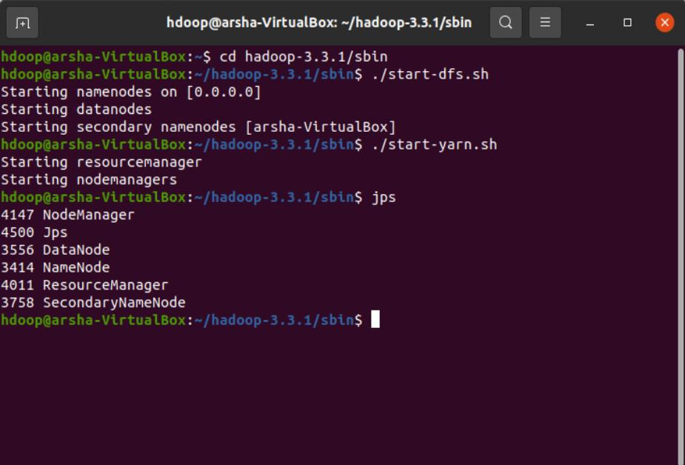

* Now create input directory in HDFS. Run command - hdfs dfs -mkdir /input
* Now copy your data.txt to this input directory. Run command –

hdfs dfs -put /home/arsha/Desktop/data.txt /input

* Now to check the content of this data.txt, run command – hdfs dfs -cat /input/data.txt

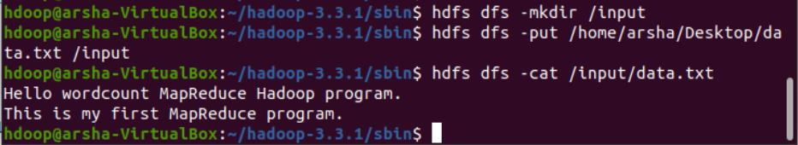

1. Now Run WordCount.jar that we have created earlier to see the output. For this command format will be

‘hadoop jar <your jar file location> <packagename.classname> /<text file location in HDFS> /<HDFS output directory name>’

There is no need to create output directory in HDFS

Run command –

Hadoop jar /home/arsha/eclipse-workspace/WordCount.jar PkgWordCount.WordCount /input /out

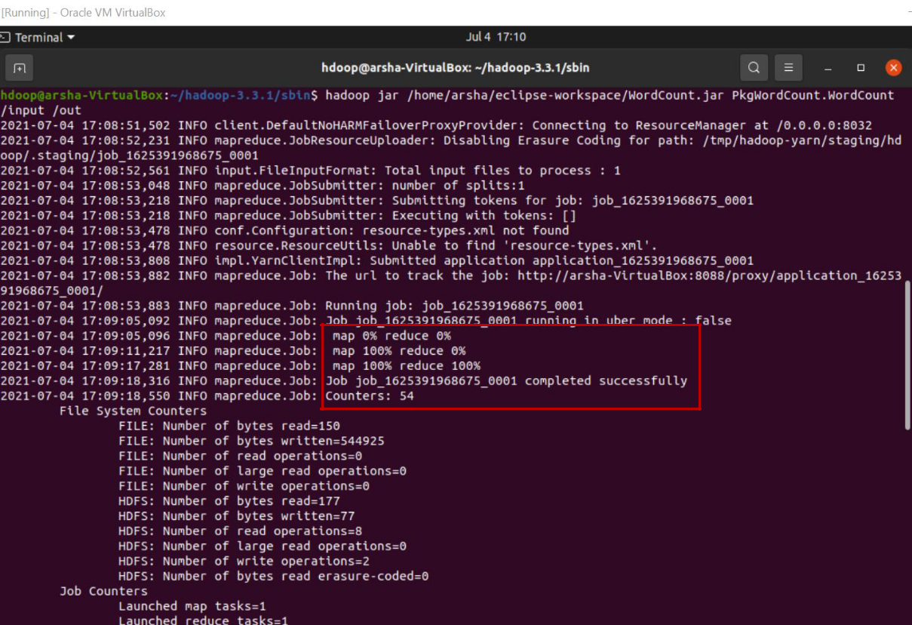

As you can see mapping and reducing job is completed successfully.

1. Now to see the output run command - hadoop fs -cat /out/*

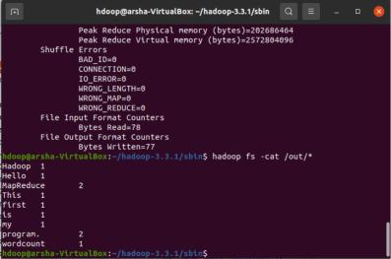

1. See the output on Browser.
   * Open **localhost:8088** to open Resource Manager.

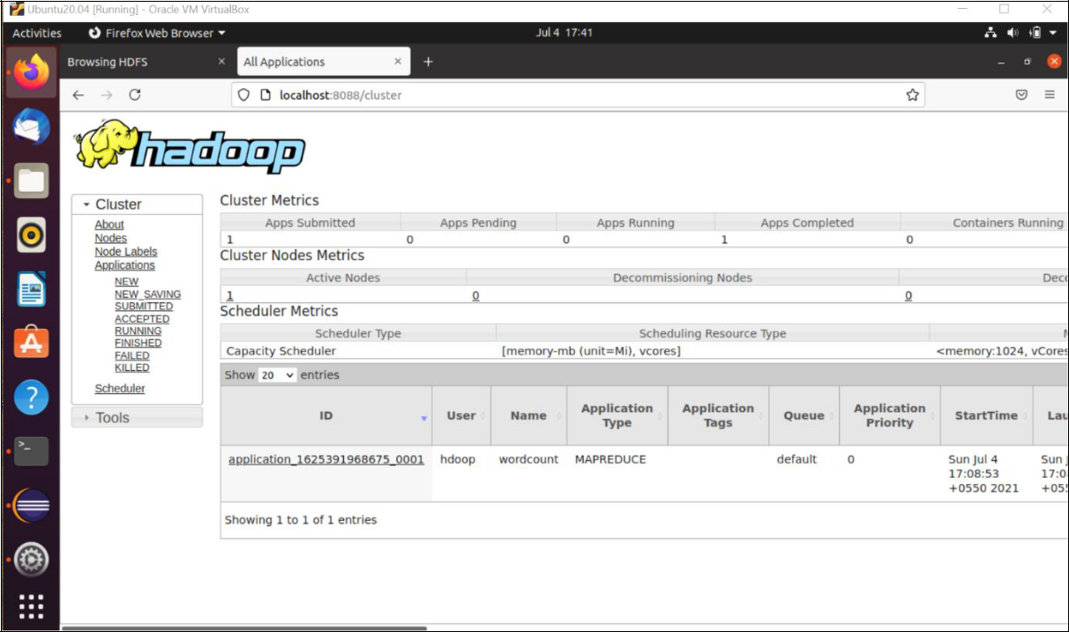

You can see 1 active node and 1 app submitted which is our **wordcount** mapreduce app.

* Now Open **localhost:9870** and click on **Browse the file system** under **Utilities.** You can see HDFS as follows

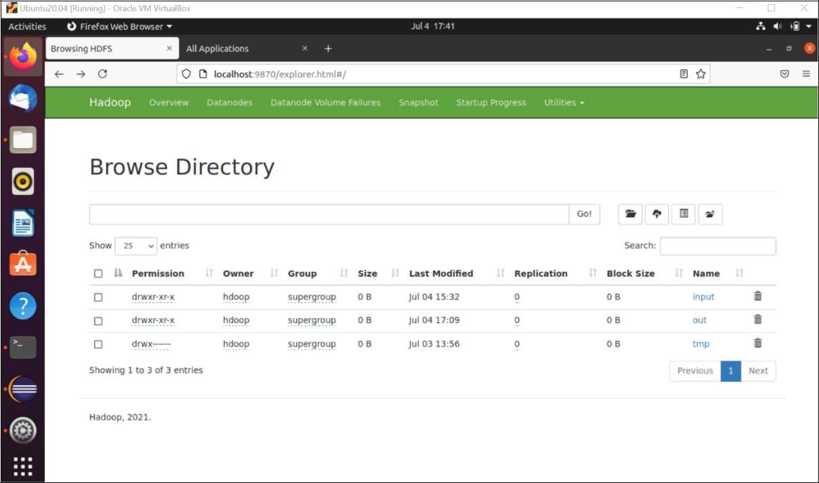

* Click **input** directory and you can see the **data.txt**

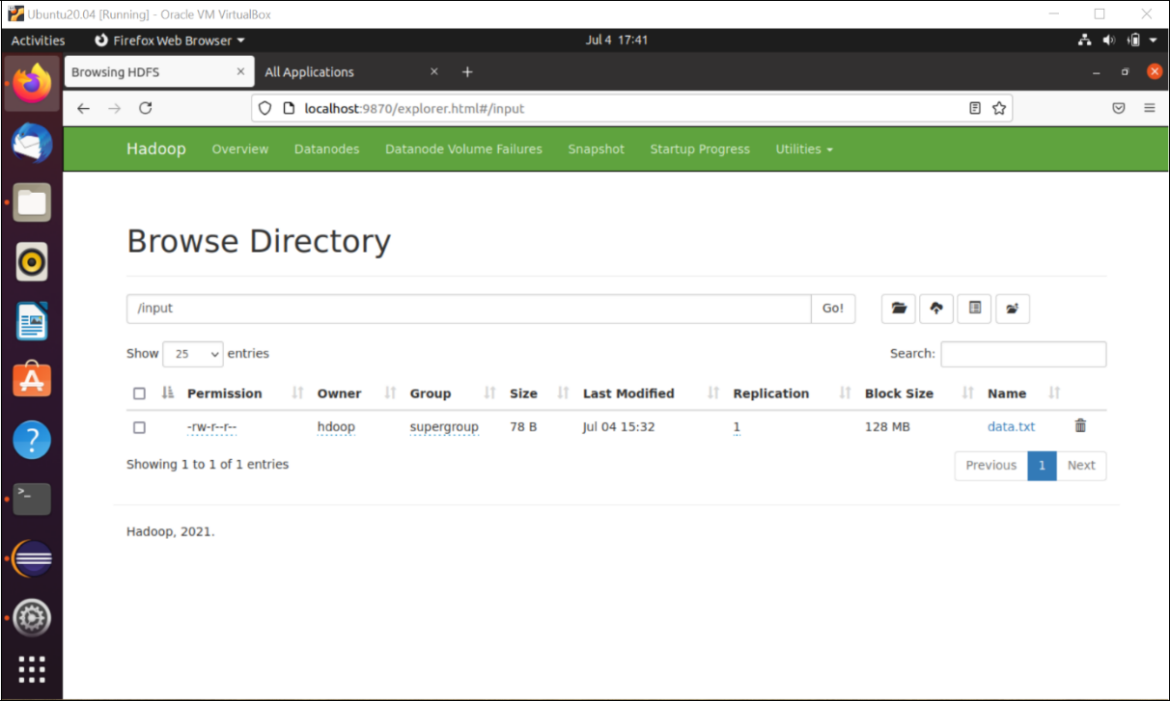

* To see the content of file click on data.txt and then click **Head the file**

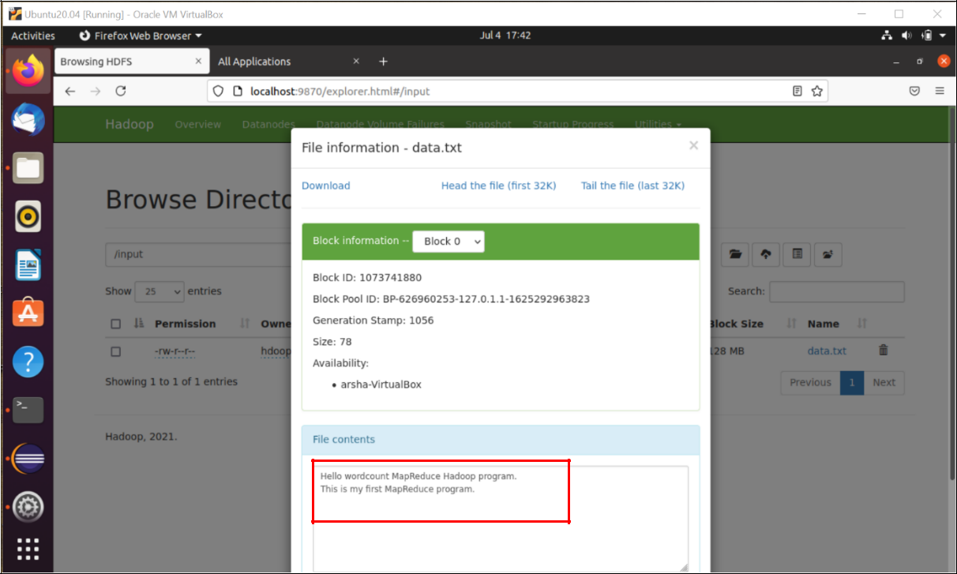

* To see output of wordcount program, go to out directory and click **part-r-00000**

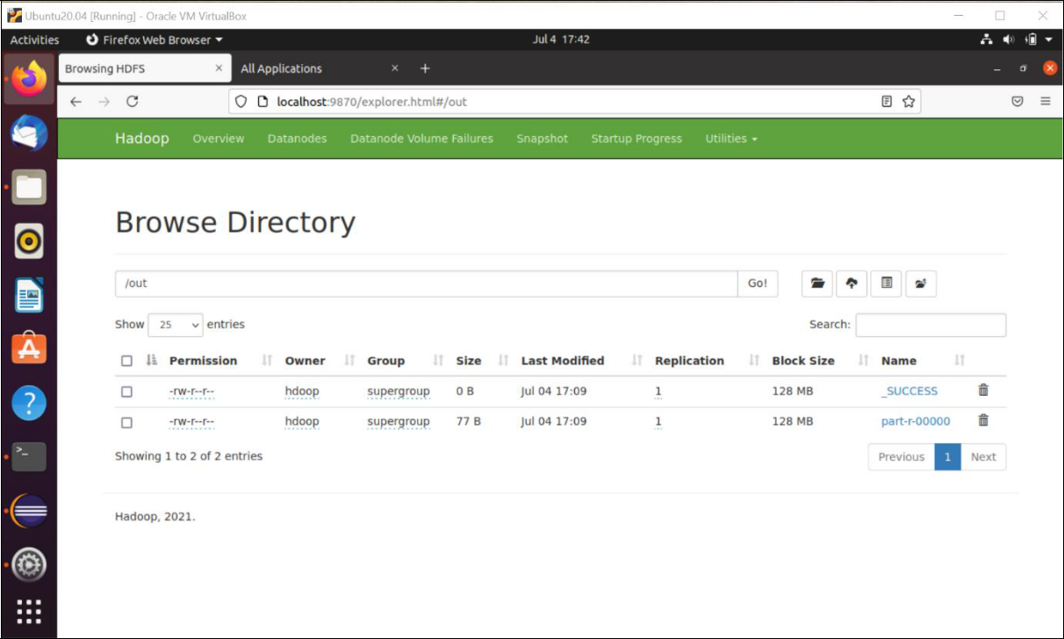

* Click **Head the file.**

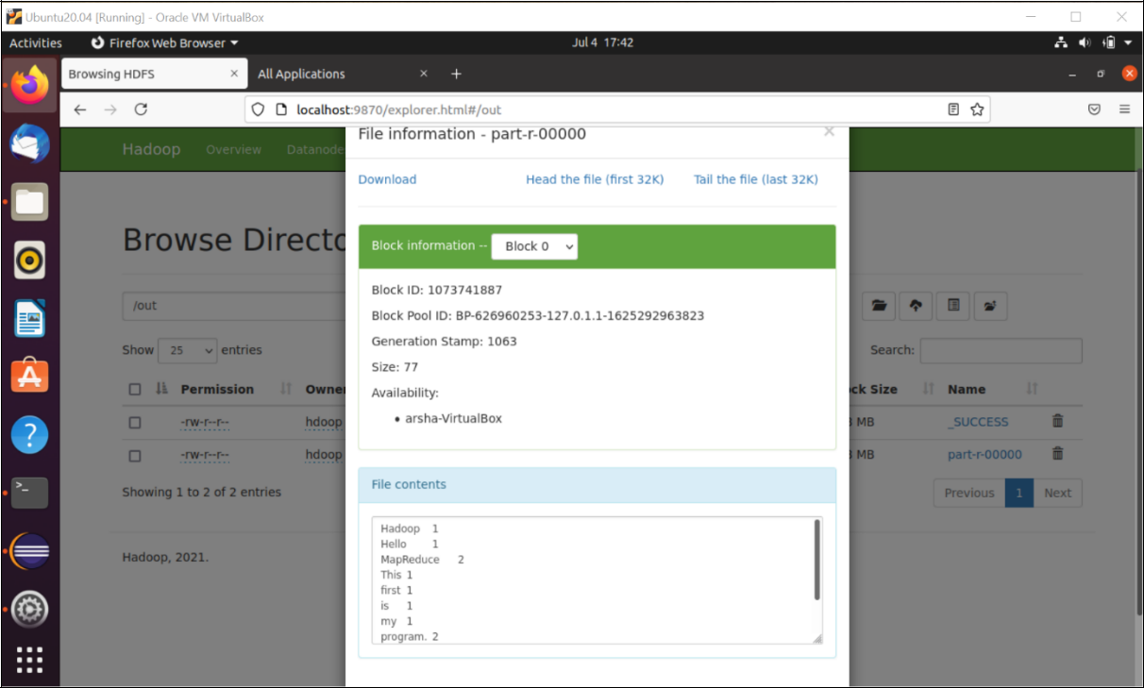

1. Stop all the daemons. Run command-

./stop-all.sh

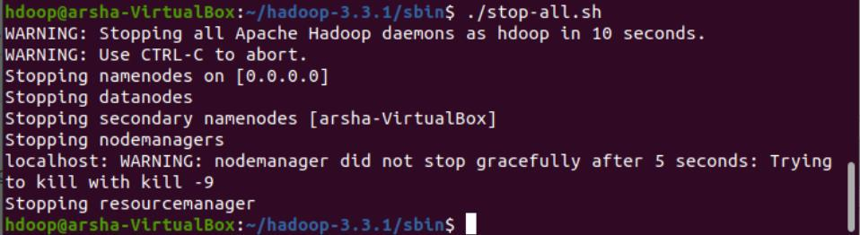

**Practical No. 3**

**Aim: Mongo DB: Installation and Creation of database and Collection CRUD Document: Insert, Query, update and Delete Document.**

**Requirement**

1. PyMongo
2. Mongo Database

**Step A: Install Mongo database**

**Step 1)** Go to (https://www.mongodb.com/download-center/community) and Download MongoDB Community Server. We will install the 64-bit version for Windows.

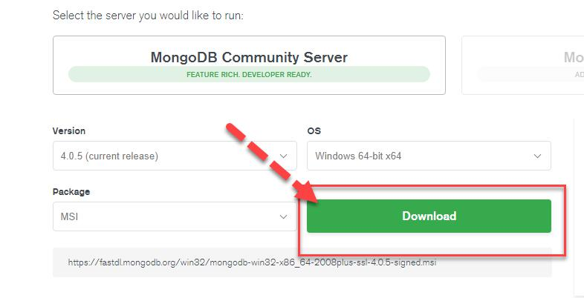

**Step 2)** Once download is complete open the msi file. Click Next in the start up screen

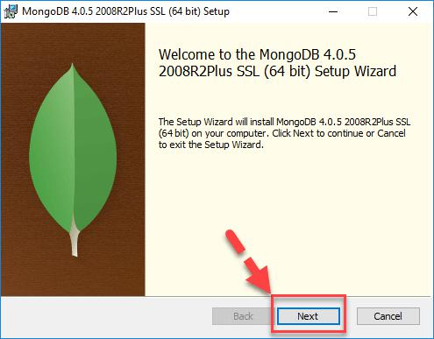

**Step 3)**

1. Accept the End-User License Agreement
2. Click Next

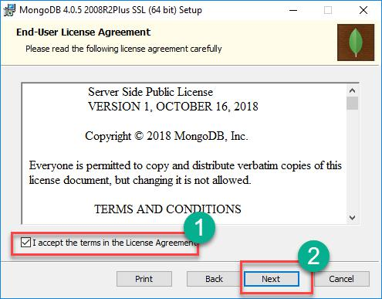

**Step 4)** Click on the "complete" button to install all of the components. The custom

option can be used to install selective components or if you want to change the location of the installation.

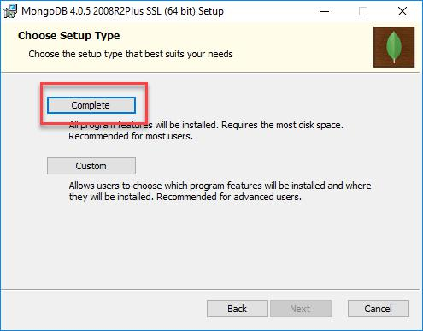

**Step 5)**

1. Select “Run service as Network Service user”. make a note of the data directory, we’ll need this later.
2. Click Next

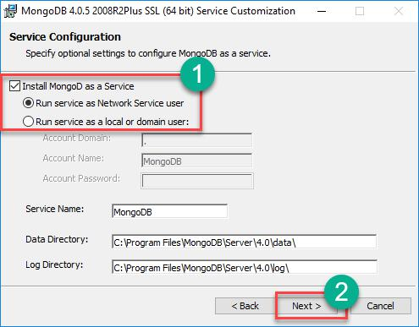

**Step 6)** Click on the Install button to start the installation.

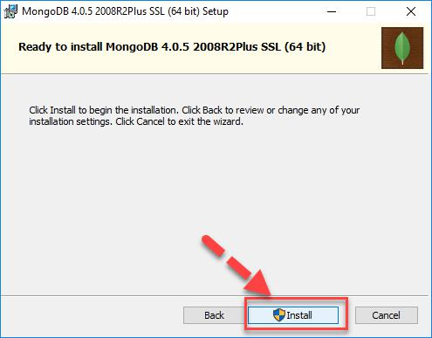

**Step 7)** Installation begins. Click Next once completed

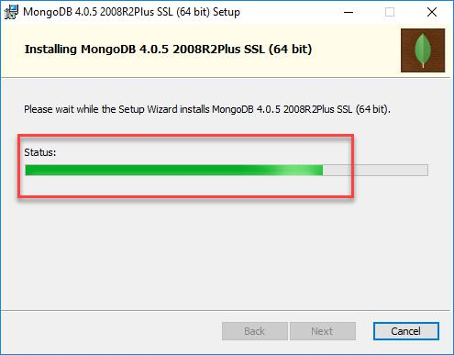

**Step 8) Click** on the Finish button to complete the installation

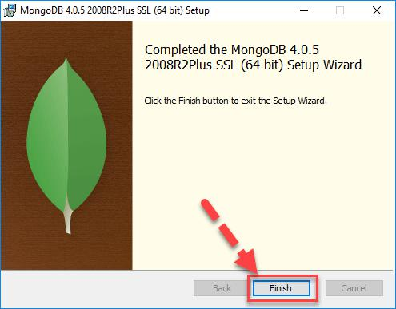

**Test Mongodb**

**Step 1)** Go to " C:\Program Files\MongoDB\Server\4.0\bin" and double click on mongo.exe. Alternatively, you can also click on the MongoDB desktop item

**Create the directory where MongoDB will store it’s files.** From the command prompt run md \data\db . This is the default location. However, other locations can be specified using the --dbpath parameter. See the Mongo docs for more information.

* + 1. C:\>md data o C:\md data\db

o C:\Program Files\MongoDB\Server\4.05\bin>mongod.exe --dbpath "C:\data"

**Start the mongodb daemon** by running C:\mongodb\bin\mongod.exe in the Command Prompt. Or by running, C:\path\to\mongodb\bin\mongod.exe

**Connect to MongoDB using the Mongo shell** While the MongoDB daemon is running, from a different Command prompt window

run C:\mongodb\bin\mongo.exe

C:\Program Files\MongoDB\Server\4.05\bin>mongod.exe --dbpath "C:\data"

C:\Program Files\MongoDB\Server\4.05\bin>mongo.exe

**Step B: Install PyMongo**

C:\Users*Your Name*\AppData\Local\Programs\Python\Python36-32\Scripts>python -m pip install pymongo

**Now you have downloaded and installed a mongoDB driver.**

Test PyMongo

***demo_mongodb_test.py:***

import pymongo

**Program 1: Creating a Database**

import pymongo

myclient = pymongo.MongoClient("mongodb://localhost:27017/")

mydb = myclient["mybigdata"]

print(myclient.list_database_names())

**Progam 2: Creating a Collection**

import pymongo

myclient = pymongo.MongoClient("mongodb://localhost:27017/")

mydb = myclient["mybigdata"]

mycol=mydb[“student’]

print(mydb.list_collection_names())

**Progam 3: Insert into Collection**

import pymongo

myclient = pymongo.MongoClient("mongodb://localhost:27017/")

mydb = myclient["mybigdata"]

mycol=mydb[“student’]

mydict={“name”:”Kaushal”, “address”:”Mumbai”}

x=mycol.insert_one(mydict) # insert_one(containing the name(s) and value(s) of each field

**Program 4: Insert Multiple data into Collection** import pymongo

myclient = pymongo.MongoClient("mongodb://localhost:27017/")

mydb = myclient["mybigdata"]

mycol=mydb[“student’]

**mylist=[**{“name”:”Kaushal”, “address”:”Mumbai”}, {“name”:”A”, “address”:”Mumbai”}, {“name”:”B”, “address”:”Pune”}, {“name”:”C”, “address”:”Pune”},**]** **x=mycol.insert_many(mylist)**

**Test in Mongodb to check database and data inserted in collection**

1. If you want to check your database list, use the command **show dbs** in mongo command prompt
2. If you want to use a database with name mybigdata, then use database statement would be as follow: **use mybigdata**
3. If you want to check collection in mongodb use the command **show collections**
4. If you want to display all the data from collection: **db.collection_name.find()** or **db.collection_name.find().pretty()**

**Practical No. 4**

Aim: Hive: Introduction Creation of Database and Table, Hive Partition, Hive Built in Function and Operators, Hive View and Index.

Steps for hive installation

* Download and Unzip Hive
* Edit .bashrc file
* Edit hive-config.sh file
* Create Hive directories in HDFS
* Initiate Derby database
* Configure hive-site.xml file

download and unzip Hive

=============================

wget https://downloads.apache.org/hive/hive-3.1.2/apache-hive-3.1.2-bin.tar.gz

tar xzf apache-hive-3.1.2-bin.tar.gz

Edit .bashrc file

========================

sudo nano .bashrc

export HIVE_HOME= /home/hdoop/apache-hive-3.1.2-bin

export PATH=$PATH:$HIVE_HOME/bin

source ~/.bashrc

Edit hive-config.sh file

====================================

sudo nano $HIVE_HOME/bin/hive-config.sh

export HADOOP_HOME=/home/hdoop/hadoop-3.2.1

Create Hive directories in HDFS

===================================

hdfs dfs -mkdir /tmp

hdfs dfs -chmod g+w /tmp

hdfs dfs -mkdir -p /user/hive/warehouse

hdfs dfs -chmod g+w /user/hive/warehouse

Fixing guava problem – Additional step

=================

rm $HIVE_HOME/lib/guava-19.0.jar

cp $HADOOP_HOME/share/hadoop/hdfs/lib/guava-27.0-jre.jar $HIVE_HOME/lib/

Initialize Derby and hive

============================

schematool -initSchema -dbType derby

hive

optional Step – Edit hive-site.xml

===========

cd $HIVE_HOME/conf

cp hive-default.xml.template hive-site.xml

sudo nano hive-site.xml – change metastore location to above created hdfs path(/user/hive/warehouse)

**Practical No. 5**

Aim: Visualization: Connect to data, Build Charts and Analyze Data, Create Dashboard, Create Stories using Tableau.

### **Downloading and Installing Tableau Public**

1- Visit the URL <https://public.tableau.com/en-us/s/download> on your web browser. Once the window opens, enter your email id when asked, and click on the “Download the App” button.

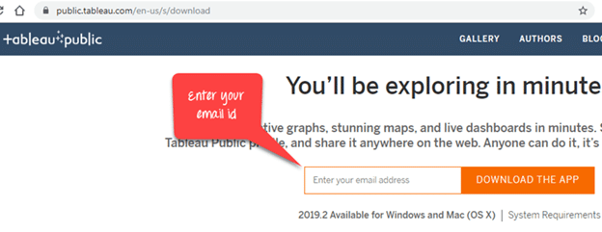

2- The file will start downloading in “.exe” format. You can view the download progress on the bottom-left corner of the tab.

3- Once the progress is 100 percent, open the file. Accept the terms and conditions by selecting the checklist boxes and click on the “Install” button.

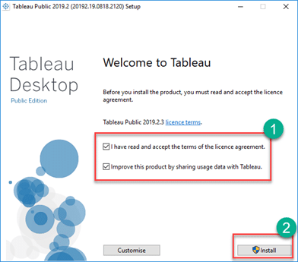

4- Once the installation is complete, open Tableau and start the screen of Tableau Public as shown below.

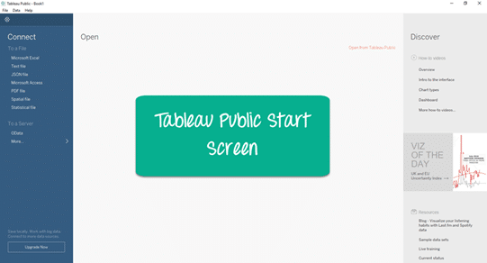

### **Downloading and Installing Tableau Desktop**

1- Enter this URL  <https://www.tableau.com/products/desktop> on your web browser.

2- Click on the “TRY NOW” button in the top-right corner of the website as shown below.



3-  Once you click on the “TRY NOW” button, you will be redirected to a page that will ask you to feed in your official email address. After filling in the email address, click on the “DOWNLOAD FREE TRIAL” button.

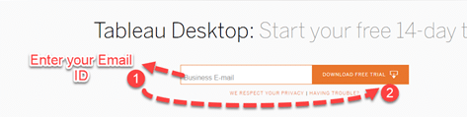

4- The latest version of Tableau Desktop will start downloading, and you will be able to view the download progress in the bottom-left corner of the screen.

5- Once downloaded, open the file. Accept the terms and conditions, and click on the “Install” button.

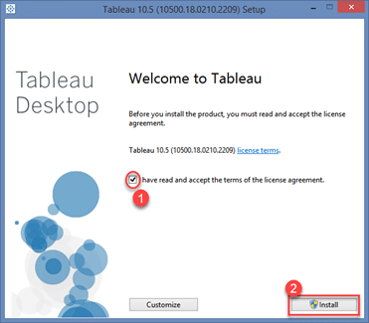

6- A pop-up option will appear asking for the approval of the administrator to install the software. Click on “YES” to approve and move further.

7- On approval, the installation will start. On the completion of the installation, open Tableau.

8- This is the final stage that asks for registration. Click on “Activate Tableau” and enter your license details or credentials.

9- Click on “Start Trial Now” and wait for the registration process to complete.

10- Once it is completed, open the Tableau screen as shown below.

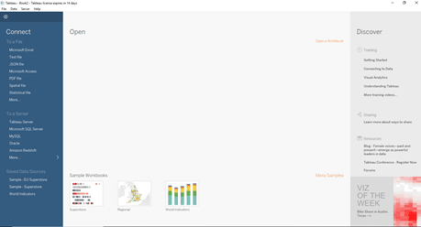

## **Connect from Tableau Desktop**

Connect to Data:

a. Open Tableau Desktop and click on the "Connect to Data" button.

b. Choose the type of data source you want to connect to (e.g., Excel, CSV, SQL Server, etc.) and select the file or database.

c. If necessary, enter any login credentials or other connection details required to access the data.

d. Tableau will automatically import the data into a new worksheet.

**Build Charts and Analyze Data:**

1. In the worksheet, select the data you want to visualize and drag it onto the "Columns" and "Rows" shelves to create a chart.
2. Choose the type of chart you want to create from the "Show Me" panel (e.g., bar chart, line chart, scatter plot, etc.).
3. Use the "Marks" card to customize the appearance of the chart (e.g., color, size, shape, etc.).
4. Use the "Filters" pane to refine the data displayed in the chart by selecting or excluding specific values or ranges.
5. Use the "Analytics" pane to add statistical functions or trend lines to the chart for deeper analysis.

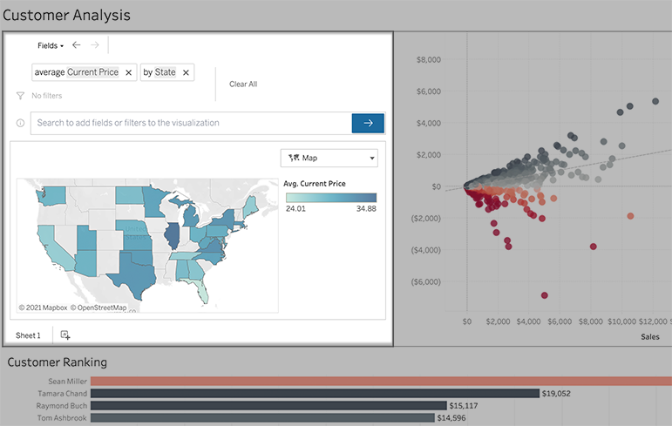

**Create Dashboard:**

a. Click on the "New Dashboard" button to create a new dashboard.

b. Drag the charts or worksheets you want to include on the dashboard onto the canvas.

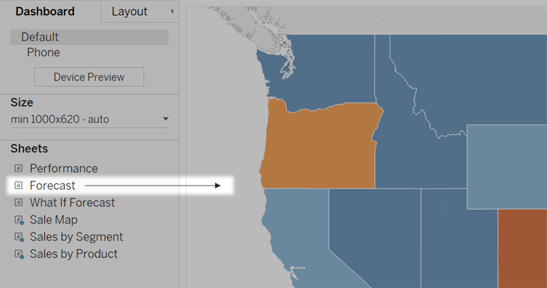

c. Use the "Dashboard" menu to customize the layout and formatting of the dashboard (e.g., adding titles, adjusting the size and position of the components, etc.).

d. Use the "Actions" pane to create interactivity between the components on the dashboard (e.g., selecting a value in one chart filters the data displayed in another chart).

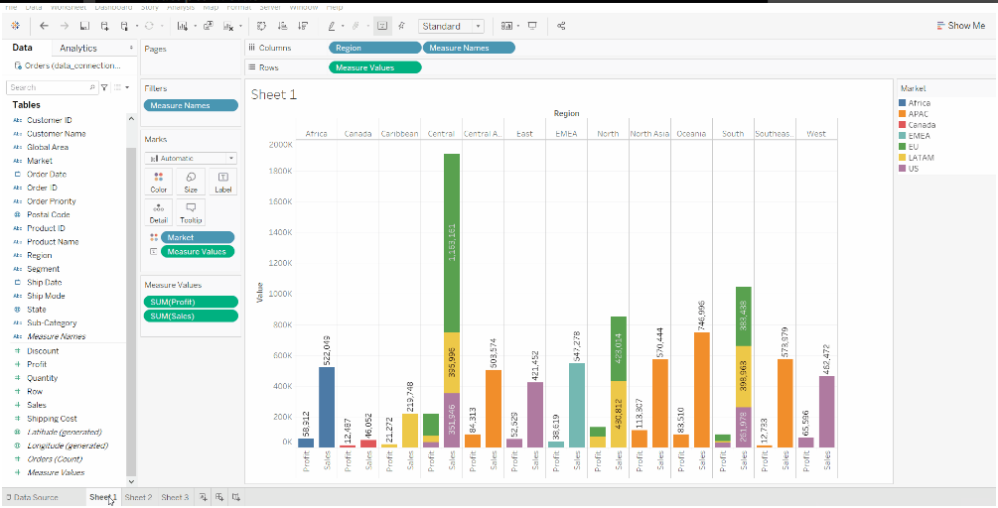

**Create Stories:**

a. Click on the "New Story" button to create a new story.

b. Use the "Story" menu to add slides to the story and customize the layout and formatting of each slide (e.g., adding titles, adjusting the size and position of the components, etc.).

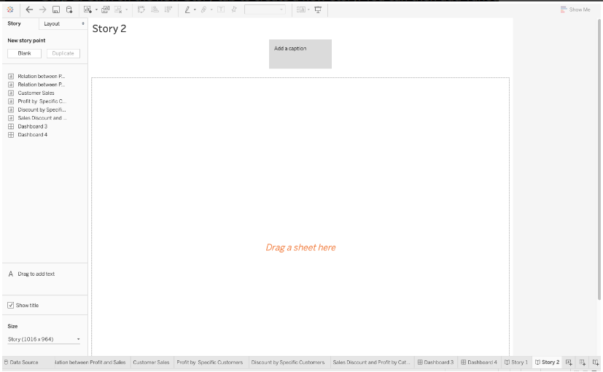

c. Use the "Sheets" pane to select the worksheets or dashboards you want to include on each slide.

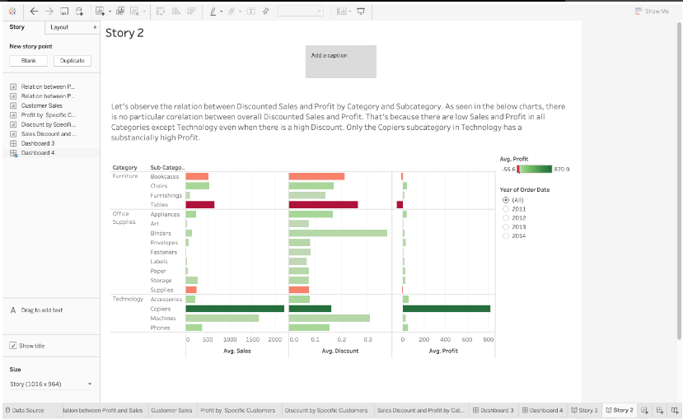

d. Use the "Annotations" pane to add annotations, text boxes, or other visual aids to explain the data and insights on each slide.

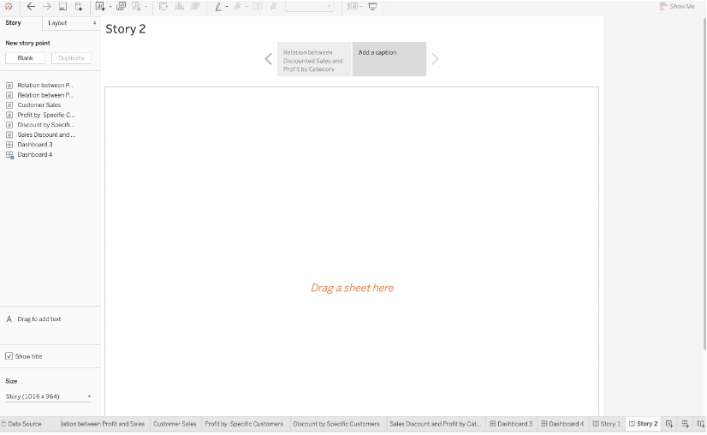

1. Use the "Navigation" pane to create a sequence of slides and add transitions between them for a more engaging storytelling experience.

